**Exercise 1. Spatial Definition of Stock/Data-limited Methods**

**Exercise Goal:**

1. Identify ways to approach defining an LRP for the Arctic sardine stock in a data-limited context, where the “stock” area contains multiple management components.

The fictional Arctic sardine stock consists of three management units (Figure 1) but would be prescribed to the Fish Stocks Provisions as a single stock. A single LRP will be required for the stock. Data types and coverage differs among the three management components (Table 2). The majority of the stock landings are taken from MU1 (~75% of landings). Consequently, MU1 is the primary focus of data collection and reporting.

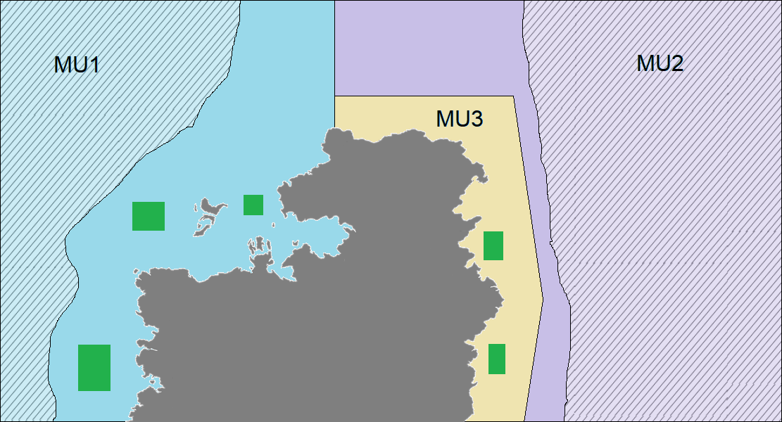

**Figure 1. Map of the Arctic sardine management units (MU1, MU2, MU3).**

Green polygons = known spawning areas and locations of acoustic surveys during the spawning season

Hatched area = groundfish bottom trawl survey coverage

Consider the following two approaches of defining an LRP for the Arctic sardine stock:

* An LRP based on the entire stock that includes all three management units.
* An LRP based on MU1 only.

**Candidate Criteria for Best-Practice Indicators and LRPs:**

* Consistent with an objective to avoid serious harm to the stock
* Based on the best available information
* Operationally useful
* Reliably estimated

**Exercise Questions:**

1. Evaluate the pros and cons of various data sources (catch, CPUE, bottom trawl survey index, acoustic survey index) that differ in terms of spatial and temporal coverage and which could serve as indicators of stock status.
2. Select a spatial area (entire stock or MU1 only) and define an LRP for that area using an indicator generated from the dataset provided. If more than one LRP is considered, evaluate the pros and cons of each.
3. As a group, prepare a 1-2 slide (< 5 minute) presentation to explain

* The spatial area chosen
* The preferred stock status indicator – pros/cons of choice
* The preferred LRP – what assumptions?
* The rationale for each (including how choices reflect candidate best practice criteria)
* Include a time series plot of the indicator and add a line to represent the LRP.
* Put on your manager hat and describe how the LRP could be operationalized (risk tolerance, time frames)
* What are the assumptions needed to select a single LRP for the stock, and what are the consequences of a failure of assumptions? (Risk of scale mismatch of control).

Table 1. Data Files for Exercise 1

|  |  |  |
| --- | --- | --- |
| File Type | File Name | Description |
|  | Exercise 1 Background Figures.html | Fishery background and figures |
| CSV layer | ex1_landings.csv | Landings by MU and year |
| CSV layer | ex1_indices.csv | Purse seine catch and effort for MU1 by year  Survey indices for entire stock are and MU1 by year |
| C:\Users\barretttj\AppData\Local\Microsoft\Windows\INetCache\Content.MSO\3B9046F.tmp | ex1.R | R script that imports data with plots and calculations started |
| C:\Users\barretttj\AppData\Local\Microsoft\Windows\INetCache\Content.MSO\3B9046F.tmp | functions.R | R script with functions (in main LRP directory) |

Table 2. Data scenario by area

|  |  |  |  |
| --- | --- | --- | --- |
| MU | Indicator | Data File and Column | Units |
| Entire stock area | Landings (years 1-50) | ex1_landings.csv  Landings_kt | kt |
| Relative index of total (benthic) biomass from groundfish bottom trawl survey (years 9-50)  [index covers part of MU1 and MU2] | ex1_indices.csv  BT_Index_MU1_2 | kt |
| Relative index of SSB from acoustic surveys on the spawning grounds (years 26-50)  [index covers spawning grounds in MU1 and MU3, spawning locations unknown in MU2] | ex1_indices.csv  Ac _Index_MU1_3 | kt |
| MU1 | Total Landings (years 1-50) | Can be obtained from ex1_landings.csv | kt |
| Purse Seine Landings (years 1-50) | ex1_indices.csv PS_Catch_MU1 | kt |
| Purse Seine Effort (years 11-50) | ex1_indices.csv PS_Effort_MU1 | # of trips |
| Relative index of total (benthic) biomass from groundfish bottom trawl survey (years 9-50)  [index covers part of MU1] | ex1_indices.csv BT_Index_MU1 | kt |
| Relative index of SSB from acoustic surveys on the spawning grounds (years 26-50)  [complete coverage of spawning areas in MU1] | ex1_indices.csv Ac_Index_MU1 | kt |